**Project Design Phase-II**

**Technology Stack (Architecture & Stack)**

|  |  |
| --- | --- |
| Date | 16 October 2022 |
| Team ID | PNT2022TMID35083 |
| Project Name | IoT Based Safety Gadget for Child Safety Monitoring and Notification |
| Maximum Marks | 4 Marks |

**Technical Architecture:**

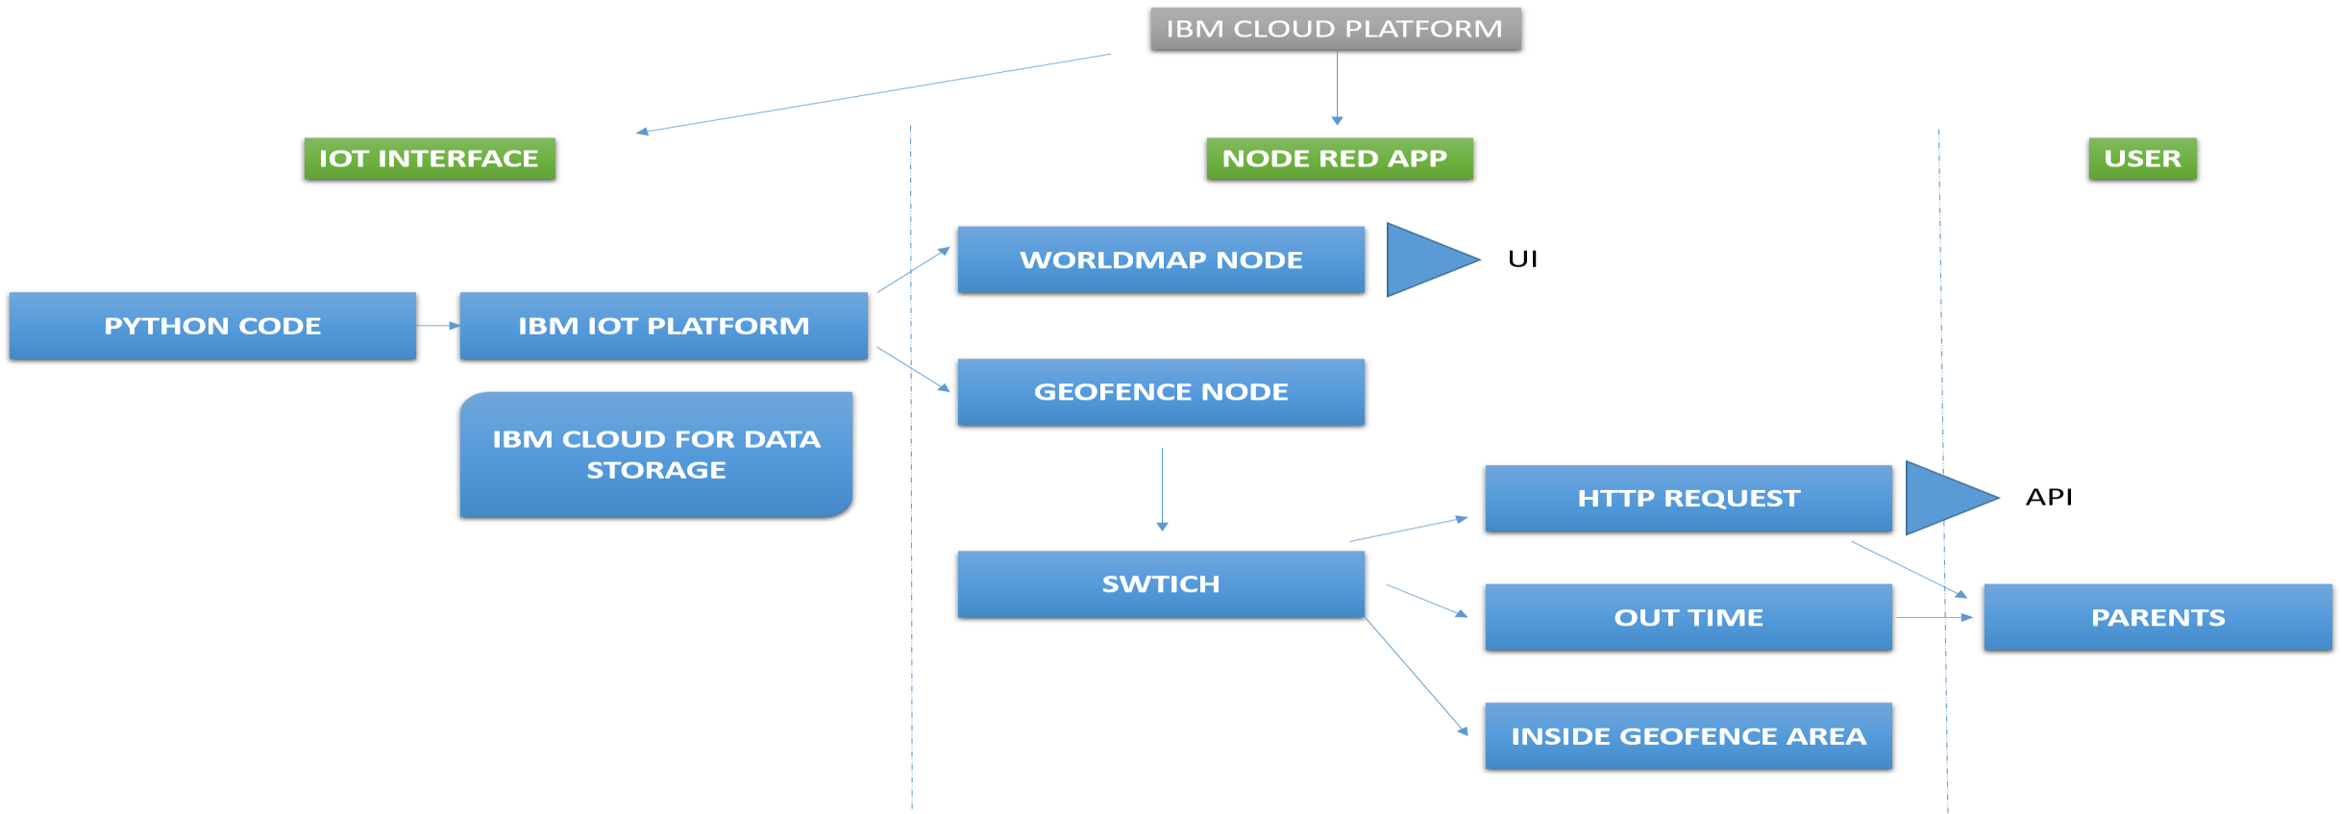

|  |  |  |  |
| --- | --- | --- | --- |
| **S.No** | **Component** | **Description** | **Technology** |
| 1. | User Interface | Coordinates mapped to location | World Map Node in NODE RED facility IBM Watson STT service (map) |

**Table-1 : Components & Technologies:**

|  |  |  |  |
| --- | --- | --- | --- |
| 2. | Application Logic-1 | Updating geographical coordinates of the child’s location to IBM IoT platform periodically  (in this project we use static inputs) | Java / Python |
| 3. | Application Logic-2 | Checks if location in within safe zone radius or not  Radius can be set as per requirements | Geofence Node in NODE RED facility IBM Watson STT service (map) |
| 4. | Cloud Database | Database Service on Cloud | IBM Cloudant |
| 5. | File Storage | File storage requirements | IBM Block Storage |
| 6. | External API-1 | To send message to parents if child is out of safe zone radius set | fast2sms API |
| 7. | Infrastructure (Server / Cloud) | Deployment of NODE RED app and further usage | Cloud Foundry |

|  |  |  |  |
| --- | --- | --- | --- |
| **S.No** | **Characteristics** | **Description** | **Technology** |

|  |  |  |  |
| --- | --- | --- | --- |
| 1. | Scalable Architecture | We need to update the implemented application  periodically | IOT (Internet Of Things) |

**Table-2: Application Characteristics:**

|  |  |  |  |
| --- | --- | --- | --- |
| 2. | Availability | To make it available 24/7 for uninterrupted services we have implemented in distributed servers (cloud) | IBM CLOUD |
| 3. | Performance | Network conditions should be stable even at worst conditions | High speed network plays a major role  in efficiency |